The following is an example change request to function as a template for actual requests. Please complete the template with as much detail as possible. The SRS chair, vice chair, and the compliance coordinator can be contacted for assistance.
A SRS member should submit the completed request by posting the document on the SRS team site.
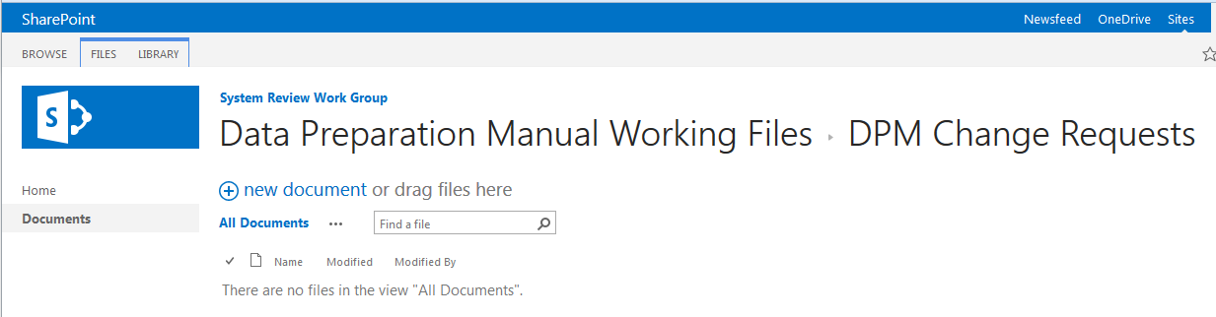
Post change request here

Change Summary
An increasing number of resources are being pseudo-tied. This presents a challenge for WECC base cases. WECC bases case areas represent contiguous elements. However, a pseudo tied resource can be physically interconnected to one area but within a Balancing Authority Area (BAA) several states away. This situation requires additional coordination between areas since the operation of the generation facility directly impacts the transmission system to which the generator is interconnected, but the output of the resource would be based on the needs of the BAA.

Schedule
Incorporate language into Data Preparation Manual (DPM): Inclusion in 2024 DPM.
Adherence to revised DPM language: Same as 2024 DPM.

Detailed Description
Add a section to the DPM to provide guidance on modeling pseudo ties in the WECC base case. See proposed language below.

Benefits
The following benefits are intended by completing the proposed DPM change request:
- Define coordination required to accurately represent pseudo ties in WECC base cases

Cost
- None, coordination would be part of current WECC base case building practices.

Alternatives
No alternatives

Proposed Edits
The following section is proposed for inclusion in the DPM.

Pseudo Ties
General Requirements
- It is recommended that elements be modeled in the area in which the facility is physically connected. Especially when the elements are located a significant distance from the Balancing Authority Area
- The Area Coordinator for the Balancing Authority Area is responsible for coordinating output.
- The Area Coordinator for the transmission interconnection facilities is responsible for coordinating voltage schedules and other case specific conditions required to capture facility operating requirements.

Examples

